ENTITY/UNIVERSITY

BSL-2 BIOSAFETY MANUAL

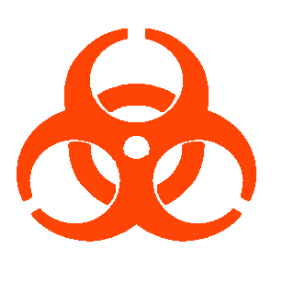

Dr. ___’s Lab
___ Building
Rooms ___

Contents
I. INTRODUCTION AND DESCRIPTION OF RESEARCH 3
II. TRAINING 4
III. LABORATORY SIGNAGE 5
IV. USE OF BIOLOGICAL SAFETY CABINET 6
V. USE AND DISPOSAL OF SHARPS 8
VI. SPILL RESPONSE PROCEDURES 10
VII. WASTE DISPOSAL PROCEDURES 11
VIII. EMERGENCY PROCEDURES 12
IX. Post-Exposure Fact Sheet 13
X. WORKING WITH ANIMALS 14
XI. SAFE HANDLING OF CRYOGENIC LIQUIDS 15
APPENDIX 1: EMERGENCY CONTACTS 16
APPENDIX 2: REFERENCES 17
APPENDIX 3: AGENT SUMMARY STATEMENT (OPTIONAL) 18
Appendix 4. BMBL BSL-2 Laboratory Criteria 19
Appendix 5. Lab Staff Training Records 24
Appendix 6. Principal Investigator’s Registered Research 25

I. INTRODUCTION AND DESCRIPTION OF RESEARCH

Insert brief description of research.

Biological agents/organisms used:
(include bacterial, viral, fungal, recombinant, human/non-human primate unfixed tissues or cells)

List organisms/biohazards here

Risk Assessment:

Please provide a brief protocol-specific risk assessment. Include consideration of parent and recombinant agent pathogenicity, virulence, infectious dose, route of transmission, host range, and stability, as well as the likelihood of exposure and consequences of exposure. How will identified risks be controlled (e.g. PPE, work practices, etc.)? Note that “replication incompetent” does not mean “non-infectious.”

Research involving recombinant/synthetic nucleic acids, infectious agents, creation of transgenic animals, unfixed non-human primate materials, or human blood, cells, or unfixed tissues must submit a research registration form through EHS at least every four years. This work may require prior review and approval by the Institutional Biosafety Committee, according to the NIH Guidelines for Research Involving Recombinant DNA Molecules. Since the university receives funding from NIH, all research at UM must comply with the NIH Guidelines.

This plan was designed as a supplement to the University Biosafety Manual to meet the requirements of Biosafety in Microbiological and Biomedical Laboratories, 5th ed.

II. TRAINING

All personnel who work in the laboratory must receive adequate instruction from their supervisor prior to beginning work. Some training is required annually. Each lab will require different trainings. For biosafety, EHS recommends:

- BSL2 training

- Bloodborne Pathogens training

- NIH Guidelines for Research Involving Recombinant/Synthetic Nucleic Acid Molecules

- Working Safely With Laboratory Animals

- Spill Prevention, Control, and Countermeasure

- Safe Handling and Use of Cryogenic Liquids

- Hazardous Waste Generator

- Shipping Infectious Materials: Training is required to commercially transport infectious materials. Contact EHS to schedule a training class.

Training on lab-specific techniques and demonstration of competency should also be required before work. Some work may require an occupational health plan, including annual physicals, pulmonary function test and fit test for use of a respirator, vaccinations, serum testing, and/or other elements of a medical plan. EHS offers guidance on designing this training on its website at ___.

The PI is required to inform laboratorians and animal handlers of any risks to immunocompromised individuals and should encourage those individuals to consult with their health care provider about these risks.

III. LABORATORY SIGNAGE

Permanent yellow warning signs containing the biohazard symbol and BSL2 designation are posted at the entrance to rooms where Risk Group 2 agents are used or stored. This system is intended for rooms where the use of BSL2 containment is expected to continue over a long time period without frequent total room decontamination. This door sign outside of the laboratory is posted and managed by EHS. Biosafety level 2 labs should have the following permanently-affixed decals: Biohazard symbol, “BSL-2” designation, and Exit Requirements. The specific agents worked with in the lab should not be listed. If any changes need to be made to the sign, including emergency contacts, please log in and update the information online. EHS will post any changes to the sign.

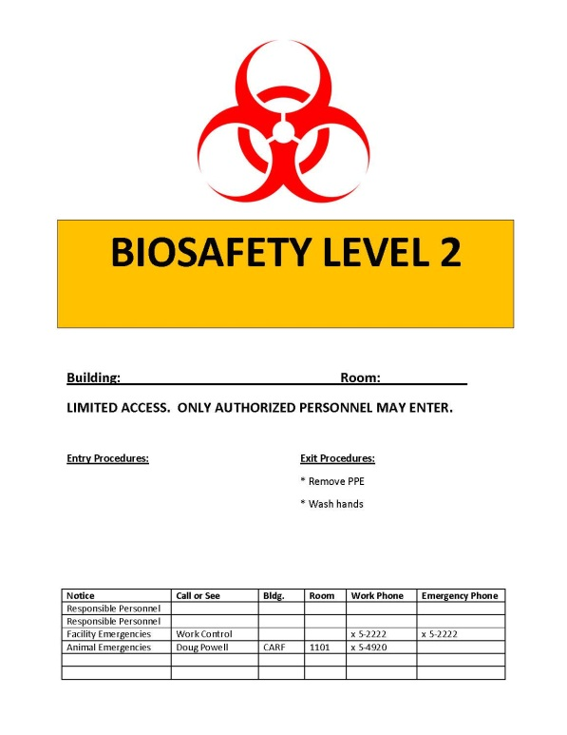
Alternative/supplemental signs will be posted at the entrance to rooms when it is expected that the agent will be removed and the room decontaminated frequently. This signage system is used for animal work with Risk Group 2 agents. The sign will be posted when the Risk Group 2 agent is present or potentially present and removed after the agent, waste, and contaminated equipment are removed, the room has been thoroughly decontaminated, and the PI has determined that the risk of exposure is negligible. When this signage system is used, the biohazard symbol and the BSL2 designation will be removed from the permanent yellow warning sign.

IV. USE OF BIOLOGICAL SAFETY CABINET

The biosafety cabinet is the primary means of protecting the researcher, the product, and the environment from biological hazards. All work with infectious agents should be manipulated in the BSC, especially those practices which could generate aerosols. Using the BSC properly includes the following:

  - Turn on cabinet fan 15 minutes before beginning work
  - Disinfect the cabinet work surface with 70% ethanol or other disinfectant and wipe surfaces.
  - Place supplies in the cabinet. Locate container inside the cabinet for disposal of pipettes. (Movement of hands in and out of the cabinet to discard pipettes into a container located outside of the cabinet creates turbulence and disrupts the air barrier that maintains sterility inside the cabinet.)
  - Work as far to the back (beyond the air split) of the BSC work space as possible.
  - Always use mechanical pipetting aids.
  - Avoid using open flames inside BSCs. If a flame is necessary, use a burner with a pilot light and place it to the rear of the workspace. Flames disrupt the airflow and contribute to the heat load inside the BSC. Flames have burned holes through HEPA filters and have caused explosions in BSCs.
  - Do not work in a BSC while a warning light or alarm is signaling.
  - Keep the work area of the BSC free of unnecessary equipment or supplies. Clutter inside the BSC may affect proper airflow and the level of protection provided.
  - Keep the front and rear grilles clear.
  - When work is completed, remove equipment and supplies from the cabinet. Wipe the work area with 70% ethanol and allow cabinet to run for 15 minutes.
  - Some BSCs are equipped with ultraviolet (UV) lights. If one is used, the tube should be wiped with 70% ethanol every two weeks, while turned off, to remove dust. UV radiation should not take the place of 70% ethanol for disinfection of the cabinet interior.
  - The UV lamp should never be on while an operator is working in the cabinet.
  - Minimize traffic around the biosafety cabinet and avoid drafts from doors and air conditioning.
  - The BSC is certified annually by a contractor. To arrange for certification, contact B & V Testing at 1-800-851-9081 or www.bandvtesting.com.
  - When using the house vacuum system, place a hydrophobic filter (C) between overflow flask (B) and vacuum port (D). Examples include Whatman Vacu-guard and Pall Gelman Vacushield in-line disk filters. Turn off the vacuum when not in use.

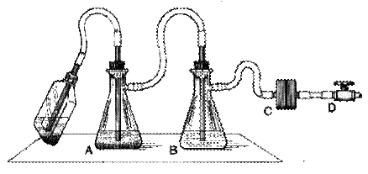

V. USE AND DISPOSAL OF SHARPS

To prevent needle stick injuries:

- Avoid using needles whenever possible.
- Replace glass materials with plastic (such as Pasteur pipettes)
- Do not bend, break, or otherwise manipulate needles by hand.
- Do not recap needles by hand. Do not remove needles from syringes by hand.
- Immediately after use, discard needle and syringe (whether contaminated or not) into puncture resistant sharps containers. RECAPPING OF NEEDLES IS PROHIBITED.
- Never discard sharps into regular trash.
- Never discard sharps into bags of biological waste.
- Use care and caution when cleaning up after procedures that require the use of syringes and needles.
- Do not overfill sharps containers. Close completely when 3/4 full, request pickup from the DES webpage at www.des.umd.edu.
- Locate sharps containers in areas in which needles are commonly used. Make containers easily accessible.

Sharps containers may be purchased from the Chemistry Stores on campus, as well as from laboratory supply distributors such as VWR and Fisher Scientific. Be sure to select sharps containers that withstand autoclaving.

In the event of a needle stick injury:

Wash the area thoroughly with soap and water. Notify supervisor immediately, fill out a First Report of Injury, and report to the Health Center.
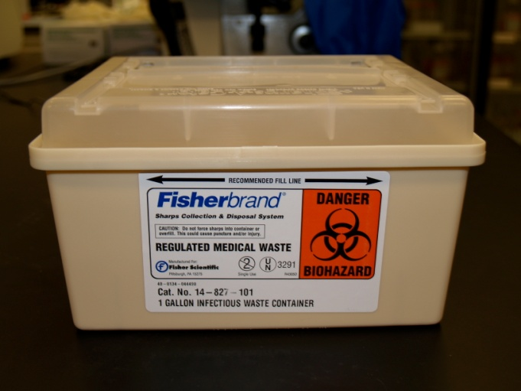
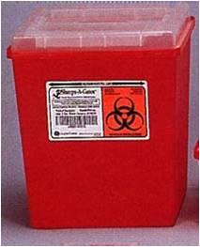
Needle Recapping

Although recapping needles is not recommended in the lab, there are times in which it must be done. In the event that needles must be filled in advance of their use, there are safe methods that can be used to "recap" them using one hand. Here are several suggestions for doing this in a safe manner:

- “One-handed scoop” method:

Place the cap on the benchtop and hold the syringe in one hand. Keep the other hand by your side. Slide the needle into the cap, then lift it up and snap it on securely using only one hand.

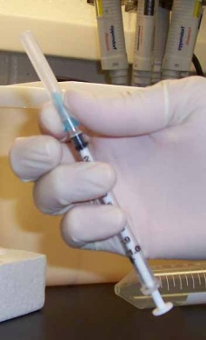
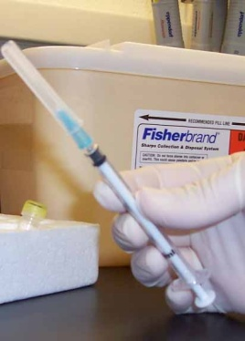

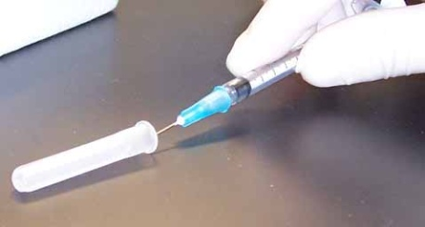

- Using a sterile 50 mL centrifuge tube or Styrofoam rack:

Place the uncapped needle inside a conical tube temporarily instead of recapping. Alternatively, put the cap inside an open centrifuge tube or rack so that the needle can be inserted into it and the cap and secured by firmly pushing the needle downward into it. There are also commercial needle recapping devices available for this purpose.
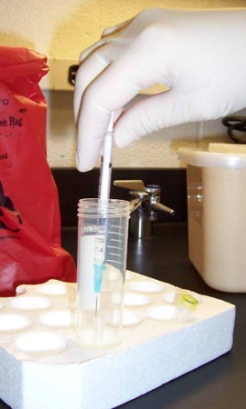

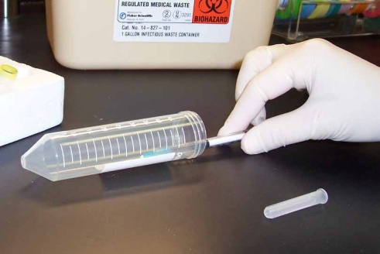

Remember to keep a designated sharps container nearby for disposal of sharps, and don’t recap unless absolutely necessary!

VI. SPILL RESPONSE PROCEDURES

Use the guidelines below for response to spills of biological materials outside of the biosafety cabinet.

Your laboratory should be equipped with a spill kit containing necessary materials for cleaning up a spill. Know where it is stored so that you can retrieve it quickly. Maintain the spill kit. Replace spill kit components as they are used to prepare for the next incident.

Immediate Action:

- Notify everyone else who is working in the room that there has been a spill and not to walk through the contaminated area.
- Don necessary protective equipment: gloves and lab coat at a minimum.
- Cover the spill with paper towels and pour 10% freshly diluted bleach or other effective disinfectant over spill. Do not spray.
- Allow to sit for at least 10 minutes or the recommended contact time depending on the disinfectant.
- Wipe with paper towels, and discard towels into autoclave bag.
- Decontaminate surrounding floor and work surface areas where splashes or larger aerosols may have settled around the spill.
- Repeat the decontamination procedure.
- Remove contaminated clothing and place in autoclave bag.
- Remove gloves and put in autoclave bag.
- Wash your hands thoroughly
- Notify your Principal Investigator (PI) as soon as possible.

The BMBL recommends that chairs used in laboratory work must be covered with a non-porous material that can be easily cleaned and decontaminated with appropriate disinfectant. If upholstered chairs cannot be replaced with non-porous ones, please address spills on these surfaces by developing a procedure for cleaning the chair cushion.

VII. WASTE DISPOSAL PROCEDURES

All personnel are responsible for maintaining a clean work area. Only trained individuals should operate the autoclave.

- Solid infectious materials
Solid infectious materials (used pipettes, flasks, Petri dishes, etc) must be disposed of in autoclave waste bags. Waste should be placed in a plastic or metal pan to contain any leaks. The autoclave should be run for one hour or sufficient time to fully decontaminate the waste. To request a biological indicator to test the autoclave’s effectiveness, contact the biosafety officer.

- Liquid infectious waste
Liquid infectious wastes, such as spent media, can be autoclaved and poured down the sink or decontaminated by adding household bleach to a final concentration of 10%, allowed to sit for at least 30 minutes, then poured down the sink in the laboratory.

- Uncontaminated waste
Uncontaminated non-sharp waste should be disposed of in the general lab waste stream.

Uncontaminated broken glass is disposed of in a sturdy cardboard box, preferably lined with a plastic bag. When full, the box should be taped closed and disposed of in the dumpster. Housekeeping will not dispose of broken glass.

- Sharps disposal
Sharps are items which pose a puncture or cutting hazard, such as glass, needles, and razors. Sharps should be disposed of in approved autoclave-resistant puncture-proof containers. Please refer to section IV of this manual for more information.

- Animal Carcasses
Place animal carcasses/tissues into a plastic bag. Double bag all carcasses when zoonotic agents are present. Store bag in freezer until removal. Disposal of animal carcasses/tissues is coordinated through the Central Animal Resource Facility (CARF). Contact CARF for removal and disposal.

- Disposal of waste into dumpsters
Lab staff is responsible for transporting autoclaved waste to the dumpsters in a timely manner. Waste bags should not be left sitting in the laboratory or autoclave room for more than a few hours. If the dumpster is full, trash bags may NOT be discarded outside the dumpster. Bags must be returned to the lab and disposed of when the dumpster has been emptied.

VIII. EMERGENCY PROCEDURES

- Fire evacuation procedures
During a fire emergency, lab staff should prioritize life safety. Cultures and animals may be put away if time allows; if not, walk to the nearest exit. Pull the fire alarm if necessary, and call 911 once outside the building.

- Power outage
In the event of a power outage, put away cultures and animals. Remove PPE and exit the lab normally. Emergency lighting within the buildings should provide adequate visibility to exit the building. Notify the PI immediately.

- Medical emergency
In the event of a medical emergency in the lab, follow appropriate procedures depending on the hazards present. If the emergency involves a spill of hazardous agent onto the clothing or body, assist the victim to the shower or eyewash station. If the victim requires medical attention, call 911.

- Accidental exposure or needlestick
For splashes to the eyes, rinse the eyes under the eyewash for 15 minutes. If there has been a needlestick, wash the affected area thoroughly with soap and water, then report to the Health Center. Refer to the Post Exposure Fact Sheet.

IX. Post-Exposure Fact Sheet

Post-Exposure Procedures:
Salmonella typhimiruim

Characteristics: Family Enterobacteriaceae; gram negative rod; motile, aerobic and facultatively anaerobic; serological identification of somatic and flagellar antigens; over 2000 serotypes capable of causing disease.

Incubation Period: Six to 72 hours, usually about 12-36 hours

Symptoms: Salmonellosis is an acute gastroenteritis; acute infectious disease with sudden onset of abdominal pain, diarrhea, nausea and vomiting; may progress to more serious septicemia, includes focal infections, abscesses, endocarditis, pneumonia; may also cause typhoid like enteric fever; some cases develop reactive arthritis (Reiter's syndrome) which may become chronic

Infectious Dose: 100 - 1,000 organisms - ingestion; varies with multiple factors

What is a potential exposure? Ingestion, needlestick or cut with contaminated sharp object, splash to the eye, contact with broken skin.

Post-Exposure Treatment: Skin exposure / Percutaneous: Wash affected area and apply antiseptic (3% H₂O₂), report to the Health Center. Mucous membrane exposure (splash to eye): flush eyes for 15 minutes using eyewash, then report to Health Center. Ingestion: Report to the UM Health Center. Antibiotic therapy may be required. If the Health Center is closed, the After Hours NurseLine is available at (301) 314-9386.

If symptoms appear with no known incidence of exposure: Seek medical attention and inform the health care provider of the microorganisms used in the workplace.

Prevention: Biosafety level 2 practices, containment equipment, and facilities; wear lab coat and gloves; frequent handwashing is essential. Never eat in the lab. Caution should be used with sharps.

Reporting: Make note of the date and time of the incident and any relevant details. Inform principal investigator, fill out a First Report of Injury form and also report incident to EHS (x5-3960). If recombinant, the incident must be reported to NIH Office of Biotechnology Activities.

X. WORKING WITH ANIMALS

Animals must be housed, handled, and used in accordance with the federal Animal Welfare Act (P.L. 89-544, et seq) and the NIH Guide for the Care and Use of Laboratory Animals. All research involving animals must be done under a protocol approved by the University of Maryland IACUC. The Director of Laboratory Animal Resources is responsible for assuring the safety and wellbeing of the research animals.

Safety procedures for working with animals at ABSL2 containment

• Access to the animal facilities is restricted to personnel who have been advised of the potential hazard & who have a need to enter the room for program or service purposes.
• Staff will be advised of increased risks for persons who are immunocompromised, pregnant, or for whom infection might be unusually hazardous
• Personnel must wash their hands after handling cultures &/or animals, and before leaving the animal facility.
• Eating, drinking, handling contact lenses & applying cosmetics are not permitted in the animal rooms.
- • Storing of food for human use is not permitted in animal rooms.
- • Doors to animal rooms within the buildings are kept closed when animals are present. The building access doors are kept locked.
- • Work surfaces are decontaminated after use or a spill of a viable material.
- • An insect & rodent control program is in effect.
- • Bedding & waste materials from animal cages are removed in such a manner as to minimize the creation of aerosols & disposed of by autoclaving.
- • Cages are washed & decontaminated after use.
- • All waste & animal carcasses from the animal rooms are double-bagged before removal from the building for incineration.
- • Sharps shall be handled properly according to the relevant section of this manual.
- • Broken glassware is not to be handled by hand, but should be removed by mechanical means such as a broom & dustpan, tongs or forceps.
- • Spills, which result in exposure to infectious materials, should be reported to the immediate supervisor.
- • All personnel entering animal rooms shall wear appropriate protective equipment.

XI. SAFE HANDLING OF CRYOGENIC LIQUIDS

Danger! Vials immersed in liquid nitrogen may explode violently when removed! Wear face and eye protection! Plastic vials (even Nunc vials with silicon O-rings) used for storing cells in liquid nitrogen are designed to be used in the liquid nitrogen vapor phase. When immersed in the liquid phase, the liquid nitrogen frequently enters vials around the cold O-ring. When vials are removed to room temperature, the liquid nitrogen in the vial immediately begins to boil. Usually it escapes harmlessly past the seal. Occasionally (about 1 out of 1000 vials), the seal is too tight, and the pressure causes a violent rupturing of the vial, sending shards of sharp plastic rocketing in unpredictable directions with sufficient energy to lacerate the face and cause severe eye injury. When removing vials from liquid nitrogen, it is mandatory that you wear full face shields, pulled in to touch your chin so that shards can't fly under the shield. If they fit, wear goggles underneath the face shield.

EHS offers an online training, which should be taken by anyone who works with cryogenic liquids: ___.

APPENDIX 1: EMERGENCY CONTACTS

EMERGENCIES 911 (From campus phone)

Name | Office Phone # | Home/Cell Phone #
Principal Investigator,
Backup Contact,
Facilities Management Work Control Center
Department of Public Safety
Non emergency
EHS
Biosafety Officer
Radiation Safety Officer
Occupational Health Clinic
Urgent Care Clinic

APPENDIX 2: REFERENCES

University Biosafety Manual:

Biosafety in Microbiological and Biomedical Laboratories, 5th edition

http://www.cdc.gov/biosafety/publications/bmbl5/index.htm

Guidelines for Research Involving Recombinant or Synthetic Nucleic Acid Molecules (NIH Guidelines)

http://oba.od.nih.gov/rdna/nih_guidelines_oba.html

APPENDIX 3: AGENT SUMMARY STATEMENT (OPTIONAL)

The BMBL contains summary statements for many bacteria, viruses, and zoonotics. If your agent is listed in the BMBL‘s Agent Summary Statements section, you may find it useful to paste it into the biosafety manual.

http://www.cdc.gov/biosafety/publications/bmbl5/index.htm

Appendix 4. BMBL BSL-2 Laboratory Criteria

Biosafety in Microbiological and Biomedical Laboratories (BMBL)
5th Edition, February 2007
Centers for Disease Control and Prevention and National Institutes of Health

Biosafety Level 2 builds upon BSL-1. BSL-2 is suitable for work involving agents that pose moderate hazards to personnel and the environment. It differs from BSL-1 in that:

- laboratory personnel have specific training in handling pathogenic agents and are supervised by scientists competent in handling infectious agents and associated procedures;

- access to the laboratory is restricted when work is being conducted; and

- all procedures in which infectious aerosols or splashes may be created are conducted in BSCs or other physical containment equipment.

The following standard and special practices, safety equipment, and facility requirements apply to BSL-2:

Standard Microbiological Practices

1. The laboratory supervisor must enforce the institutional policies that control access to the laboratory.

2. Persons must wash their hands after working with potentially hazardous materials and before leaving the laboratory.

3. Eating, drinking, smoking, handling contact lenses, applying cosmetics, and storing food for human consumption must not be permitted in laboratory areas. Food must be stored outside the laboratory area in cabinets or refrigerators designated and used for this purpose.

4. Mouth pipetting is prohibited; mechanical pipetting devices must be used.

5. Policies for the safe handling of sharps, such as needles, scalpels, pipettes, and broken glassware must be developed and implemented. Whenever practical, laboratory supervisors should adopt improved engineering and work practice controls that reduce risk of sharps injuries.

Precautions, including those listed below, must always be taken with sharp items. These include:

- Careful management of needles and other sharps are of primary importance. Needles must not be bent, sheared, broken, recapped, removed from disposable syringes, or otherwise manipulated by hand before disposal.

- Used disposable needles and syringes must be carefully placed in conveniently located puncture-resistant containers used for sharps disposal.

- Non-disposable sharps must be placed in a hard walled container for transport to a processing area for decontamination, preferably by autoclaving.

- Broken glassware must not be handled directly. Instead, it must be removed using a brush and dustpan, tongs, or forceps. Plastic ware should be substituted for glassware whenever possible.

6. Perform all procedures to minimize the creation of splashes and/or aerosols.

7. Decontaminate work surfaces after completion of work and after any spill or splash of potentially infectious material with appropriate disinfectant.

8. Decontaminate all cultures, stocks, and other potentially infectious materials before disposal using an effective method. Depending on where the decontamination will be performed, the following methods should be used prior to transport:

- Materials to be decontaminated outside of the immediate laboratory must be placed in a durable, leak proof container and secured for transport.

- Materials to be removed from the facility for decontamination must be packed in accordance with applicable local, state, and federal regulations.

9. A sign incorporating the universal biohazard symbol must be posted at the entrance to the laboratory when infectious agents are present. Posted information must include: the laboratory’s biosafety level, the supervisor’s name (or other responsible personnel), telephone number, and required procedures for entering and exiting the laboratory. Agent information should be posted in accordance with the institutional policy.

10. An effective integrated pest management program is required. See Appendix G.

11. The laboratory supervisor must ensure that laboratory personnel receive appropriate training regarding their duties, the necessary precautions to prevent exposures, and exposure evaluation procedures. Personnel must receive annual updates or additional training when procedural or policy changes occur. Personal health status may impact an individual’s susceptibility to infection, ability to receive immunizations or prophylactic interventions. Therefore, all laboratory personnel and particularly women of child-bearing age should be provided with information regarding immune competence and conditions that may predispose them to infection. Individuals having these conditions should be encouraged to self-identify to the institution’s healthcare provider for appropriate counseling and guidance.

Special Practices

1. All persons entering the laboratory must be advised of the potential hazards and meet specific entry/exit requirements.

2. Laboratory personnel must be provided medical surveillance and offered appropriate immunizations for agents handled or potentially present in the laboratory.

3. Each institution must establish policies and procedures describing the collection and storage of serum samples from at-risk personnel.

4. A laboratory-specific biosafety manual must be prepared and adopted as policy. The biosafety manual must be available and accessible.

5. The laboratory supervisor must ensure that laboratory personnel demonstrate proficiency in standard and special microbiological practices before working with BSL-2 agents.

6. Potentially infectious materials must be placed in a durable, leak proof container during collection, handling, processing, storage, or transport within a facility.

7. Laboratory equipment should be routinely decontaminated, as well as, after spills, splashes, or other potential contamination.

- Spills involving infectious materials must be contained, decontaminated, and cleaned up by staff properly trained and equipped to work with infectious material.

- Equipment must be decontaminated before repair, maintenance, or removal from the laboratory.

8. Incidents that may result in exposure to infectious materials must be immediately evaluated and treated according to procedures described in the laboratory biosafety safety manual. All such incidents must be reported to the laboratory supervisor. Medical evaluation, surveillance, and treatment should be provided and appropriate records maintained.

9. Animals and plants not associated with the work being performed must not be permitted in the laboratory.

10. All procedures involving the manipulation of infectious materials that may generate an aerosol should be conducted within a BSC or other physical containment devices.

Safety Equipment (Primary Barriers and Personal Protective Equipment)

1. Properly maintained BSCs (preferably Class II), other appropriate personal protective equipment, or other physical containment devices must be used whenever:

- Procedures with a potential for creating infectious aerosols or splashes are conducted. These may include pipetting, centrifuging, grinding, blending, shaking, mixing, sonicating, opening containers of infectious materials, inoculating animals intranasally, and harvesting infected tissues from animals or eggs.

- High concentrations or large volumes of infectious agents are used. Such materials may be centrifuged in the open laboratory using sealed rotor heads or centrifuge safety cups.

2. Protective laboratory coats, gowns, smocks, or uniforms designated for laboratory use must be worn while working with hazardous materials. Remove protective clothing before leaving for non-laboratory areas (e.g., cafeteria, library, administrative offices). Dispose of protective clothing appropriately, or deposit it for laundering by the institution. It is recommended that laboratory clothing not be taken home.

3. Eye and face protection (goggles, mask, face shield or other splatter guard) is used for anticipated splashes or sprays of infectious or other hazardous materials when the microorganisms must be handled outside the BSC or containment device. Eye and face protection must be disposed of with other contaminated laboratory waste or decontaminated before reuse. Persons who wear contact lenses in laboratories should also wear eye protection.

4. Gloves must be worn to protect hands from exposure to hazardous materials. Glove selection should be based on an appropriate risk assessment. Alternatives to latex gloves should be available. Gloves must not be worn outside the laboratory. In addition, BSL-2 laboratory workers should:

- Change gloves when contaminated, integrity has been compromised, or when otherwise necessary. Wear two pairs of gloves when appropriate.

- Remove gloves and wash hands when work with hazardous materials has been completed and before leaving the laboratory.

- Do not wash or reuse disposable gloves. Dispose of used gloves with other contaminated laboratory waste. Hand washing protocols must be rigorously followed.

5. Eye, face and respiratory protection should be used in rooms containing infected animals as determined by the risk assessment.

Laboratory Facilities (Secondary Barriers)

1. Laboratory doors should be self-closing and have locks in accordance with the institutional policies.

2. Laboratories must have a sink for hand washing. The sink may be manually, hands-free, or automatically operated. It should be located near the exit door.

3. The laboratory should be designed so that it can be easily cleaned and decontaminated. Carpets and rugs in laboratories are not permitted.

4. Laboratory furniture must be capable of supporting anticipated loads and uses. Spaces between benches, cabinets, and equipment should be accessible for cleaning.

- Bench tops must be impervious to water and resistant to heat, organic solvents, acids, alkalis, and other chemicals.

- Chairs used in laboratory work must be covered with a non-porous material that can be easily cleaned and decontaminated with appropriate disinfectant.

5. Laboratory windows that open to the exterior are not recommended. However, if a laboratory does have windows that open to the exterior, they must be fitted with screens.

6. BSCs must be installed so that fluctuations of the room air supply and exhaust do not interfere with proper operations. BSCs should be located away from doors, windows that can be opened, heavily traveled laboratory areas, and other possible airflow disruptions.

7. Vacuum lines should be protected with High Efficiency Particulate Air (HEPA) filters, or their equivalent. Filters must be replaced as needed. Liquid disinfectant traps may be required.

8. An eyewash station must be readily available.

9. There are no specific requirements on ventilation systems. However, planning of new facilities should consider mechanical ventilation systems that provide an inward flow of air without recirculation to spaces outside of the laboratory.

10. HEPA filtered exhaust air from a Class II BSC can be safely re-circulated back into the laboratory environment if the cabinet is tested and certified at least annually and operated according to manufacturer’s recommendations. BSCs can also be connected to the laboratory exhaust system by either a thimble (canopy) connection or a direct (hard) connection. Provisions to assure proper safety cabinet performance and air system operation must be verified.

11. A method for decontaminating all laboratory wastes should be available in the facility (e.g., autoclave, chemical disinfection, incineration, or other validated decontamination method).

Appendix 5. LAB-SPECIFIC TRAINING RUBRIC

Insert methods for training lab staff in managing laboratory-specific hazards. A rubric can be found here: ___.

Appendix 6. Principal Investigator’s Registered Research

(Attach PDF copies of research forms submitted to EHS and approved by EHS and/or the Institutional Biosafety Committee. All work with infectious agents, r/s NAs, human or non-human primate unfixed tissues, cells or blood, or select agents or toxins must be registered with DES before the work begins.)

